Jonathan Mathew

CV Project 5 ImageCompression  
Due 04/19/23

Algo Steps:

Step 0:

inFile, outFile1-->open from args []

numRows, numCols, minVal, maxVal-->read from

inFile HoughAngle --> 180

HoughDist-->2 \* (the diagonal of the input image)

imgAry-->dynamically allocate

CartesianHoughAry-->dynamically allocate and initialize to zero

PolarHoughAry-->dynamically allocate and initialize to zero

offSet --> // See your lecture note.

Step 1: loadImage (inFile, imgAry) prettyPrint (imgAry, outFile1)

Step 2: buildHoughSpace (...)

Step 3: prettyPrint (CartesianHoughAry, outFile1) // with caption indicate it is Cartesian Hough space

prettyPrint (PolarHoughAry, outFile1) // with caption indicate it is Polar Hough space Step 4: close all files

img1pt-

Here is Original input

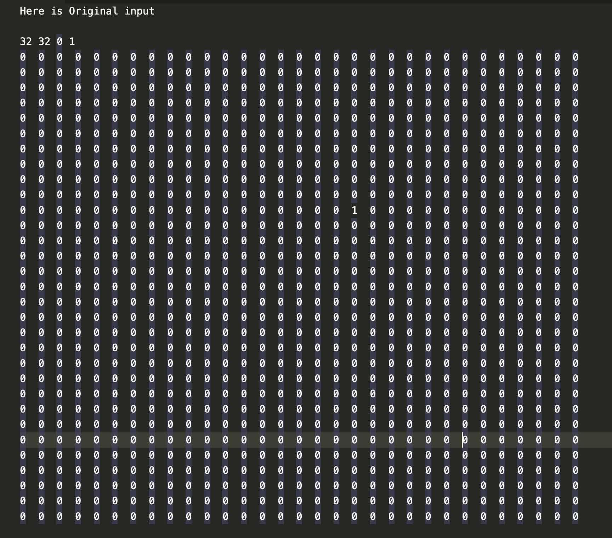

Polar

img3pt-

Cartersian

Polar

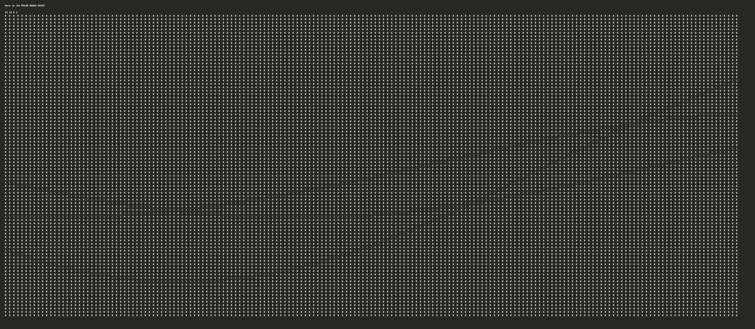

img5pt-

Cartersian

img2lines-

img5lines-

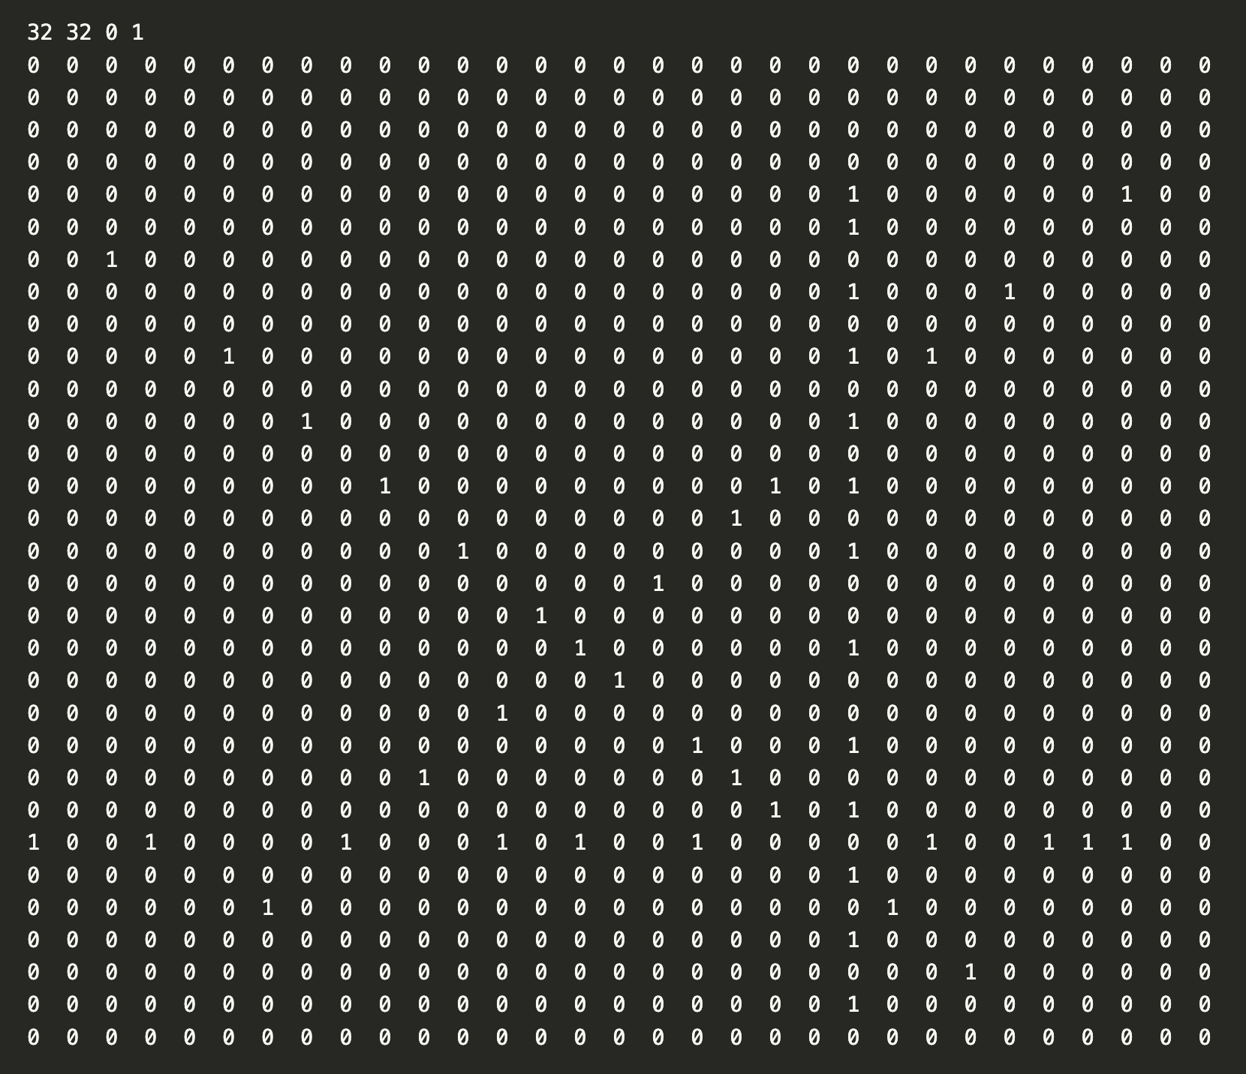

Cartersian

Polar

src

Main.java

*import* java.io.\*;  
  
*public class* Main {  
  
 *public static void* main(String[] args) *throws* IOException {  
  
 File infile = *new* File(args[0]),  
 outFile = *new* File(args[1]);  
  
 FileReader in = *new* FileReader(infile);  
 FileWriter out = *new* FileWriter(outFile);  
  
 BufferedReader br = *new* BufferedReader(in);  
 String line = br.readLine();  
 String [] header = line.split(" ");  
 *int* numRow = Integer.parseInt(header[0]),  
 numCol = Integer.parseInt(header[1]),  
 minVal = Integer.parseInt(header[2]),  
 maxVal = Integer.parseInt(header[3]);  
  
 HoughTransform proj = *new* HoughTransform(numRow, numCol, minVal, maxVal);  
  
  
 in.close();  
 in = *new* FileReader(infile);  
 proj.loadImg(in);  
 out.write("Here is Original input\n\n");  
 proj.reformatPrettyPrint(proj.imgArr, out);  
 proj.buildHSpace();  
  
 out.write("\nHere is the CARTESIAN HOUGH SPACE\n\n");  
 proj.reformatPrettyPrint(proj.cartHoughArr, out);  
 out.write("\nHere is the POLAR HOUGH SPACE\n\n");  
 proj.reformatPrettyPrint(proj.polarHoughArr, out);  
  
  
 in.close();  
 out.close();  
 }  
  
  
  
}

HoughTransform.java

*import* java.io.BufferedReader;  
*import* java.io.FileReader;  
*import* java.io.FileWriter;  
*import* java.io.IOException;  
  
*public class* HoughTransform {  
  
 *public int* numRows,  
 numCols,  
 minVal,  
 maxVal,  
 HoughDist,  
 HoughAngle,  
 angleInDegree,  
 offSet;  
  
 *public int*[][] imgArr,  
 cartHoughArr,  
 polarHoughArr;  
  
 *public double* angleInRadians;  
  
  
 *public* HoughTransform(*int* row, *int* col, *int* min, *int* max){  
 numRows = row;  
 numCols = col;  
 minVal = min;  
 maxVal = max;  
 *int* pyth = (*int*) Math.sqrt(numCols \* numCols + numRows \*numRows);  
 HoughDist = 2 \*pyth;  
 HoughAngle = 180;  
 offSet = (*int*) Math.sqrt(numRows\*numRows + numCols\*numCols);  
 imgArr = *new int*[numRows][numCols];  
 cartHoughArr = *new int*[HoughDist][HoughAngle];  
 polarHoughArr = *new int*[HoughDist][HoughAngle];  
  
 }  
  
  
 *public void* loadImg(FileReader in) *throws* IOException {  
  
 *int* count = 0;  
 BufferedReader br = *new* BufferedReader(in);  
 String line = br.readLine();  
 *while* ((line= br.readLine()) != *null*){  
 String[] data = line.split(" ");  
 *for* (*int* j = 0; j<numCols; j++){  
 imgArr[count][j] = Integer.parseInt(data[j]);  
 }  
 count++;  
 }  
  
 }  
  
 *public void* printArr(FileWriter out) *throws* IOException {  
  
 *for* (*int* r = 0; r<numRows; r++){  
 *for*(*int* c = 0; c<numCols; c++){  
 out.write(imgArr[r][c] + " ");  
 }  
 out.write("\n");  
 }  
 }  
  
 *public void* buildHSpace(){  
  
 *for* (*int* x = 0; x<numRows; x++){  
 *for*(*int* y = 0; y<numCols; y++){  
   
 *if* (imgArr[x][y]>0){  
 computeSinusoid(x,y);  
 }  
 }  
 }  
   
 }  
  
 *public void* computeSinusoid(*int* x, *int* y) {  
  
 *int* angInDegrees = 0;  
  
 *while* (angInDegrees <=179) {  
 *double* angleInRadians = (*double*) (angInDegrees \* (Math.PI/180));  
 *double* dist = cartDist(x, y, angleInRadians);  
 *int* distInt = (*int*) dist;  
 cartHoughArr[distInt][angInDegrees]++;  
 dist = polDist(x, y, angleInRadians);  
 distInt = (*int*) dist;  
 polarHoughArr[distInt][angInDegrees]++;  
 angInDegrees++;  
 }  
  
 }  
  
 *private double* polDist(*int* x, *int* y, *double* angleInRadians) {  
 *return* x\*Math.cos(angleInRadians) + y\*Math.sin(angleInRadians) + offSet;  
 }  
  
 *public double* cartDist(*int* x, *int* y, *double* angleInRadians) {  
 *double* t = angleInRadians - Math.atan((*double*)y/(*double*)x) - Math.PI/2;  
 *return* Math.sqrt(x\*x + y\*y) \* Math.cos(t) + offSet;  
 }  
  
  
 *public void* reformatPrettyPrint(*int*[][] arr, FileWriter out1) *throws* IOException {  
  
 out1.write(numRows + " " + numCols + " " + minVal + " " + maxVal + "\n");  
 String str = Integer.toString(99);  
 *int* width = str.length();  
  
 *int* ww;  
 *int* r = 1;  
  
 *while* (r < arr.length) {  
 *int* c = 1;  
 *while* (c < arr[0].length) {  
  
 out1.write(arr[r][c] + "");  
 str = Integer.toString(arr[r][c]);  
 ww = str.length();  
 *while* (ww <= width) {  
 out1.write(" ");  
 ww++;  
 }  
 c++;  
 }  
 r++;  
 out1.write("\n");  
  
 }  
 out1.write("\n");  
  
 }  
  
}